Relaxation Exercises

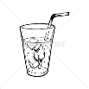

Calm Body Strategy

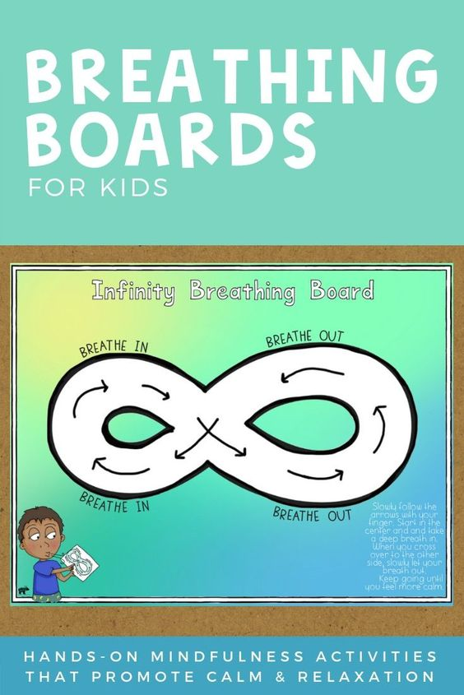

Using your finger, trace around the shape. Breathe in as you trace around one side of the figure, and breathe out while you trace around the other side of the figure. Repeat as many times as needed,

Calm Mind Strategy

Mindful Drink

Take a cold drink of water or something you like to drink. As you sip on it, really think about the feeling of the drink as it touches your lips, mouth, tongue and then goes down into your belly. Then later, try the same with something warm – like hot cocoa or soup. Which feeling did you like better? Cold or warm?